Statement of Work
#1


For

SOS Information Management System
SIMS

Between: Montana Secretary of State

and: FileONE

Prepared by: Shawn Whyte

Effective Date: _________________________

Under Contract #: SOS08-1606P

Under Contract Name: SIMS

______________________
Table of Contents
1.0 Introduction 3
1.1 Project Title: SOS Information Management System (SIMS) 3
1.2 Background 3
1.3 Objectives 3
1.4 Reference to other applicable documents 4
2.0 Staffing Roles and Responsibilities 4
2.1 Staffing 4
2.2 Roles and Responsibilities 4
2.2.1 Contractor Staff 5
2.2.2 Contractor’s Responsibilities 5
2.2.3 Agency Staff and Roles 5
2.2.4 Agency Responsibilities 7
2.3 Staffing 8
3.0 Key Assumptions 11
4.0 Risks 13
5.0 Scope of Work 13
5.1 Inclusions 14
5.2 Exclusions 14
5.3 Deliverables 14
5.4 Milestones 15
6.0 Work Approach 15
6.1 Methodology 15
6.2 Change Management 15
6.3 Task Order 15
6.4 Issue Resolution 16
6.5 Tolerance 16
6.6 Exception Planning 16
7.0 Completion Criteria and Final Acceptance Criteria 17
7.1 Completion Criteria 17
7.2 Acceptance Testing 17
7.3 Final Acceptance 18
8.0 Schedule 18
9.0 Project Management 18
10.0 State Policies Standards and Computing Environment 19
11.0 Timeline and Period of Performance 19
12.0 Compensation and Payment Schedule 19
13.0 Miscellaneous 20
14.0 Appendices 20
Execution/Signature Block 21
Appendix A – High-level Activities and Services 22
Appendix B - Deliverables List 23
Appendix C – Project Schedule 45

Statement of Work
#SOS08-1606SOW1

Introduction

Project Title: SOS Information Management System (SIMS)

This Statement of Work (SOW) is made and entered into by and between the Montana Secretary of State (Agency) and FileONE (Contractor) and it incorporates by reference the terms and conditions of Contract Number SOS08-1606P in effect between the Agency and Contractor. In case of any conflict between this SOW and the Contract, the Contract shall prevail. The Agency and Contractor agree as follows:

This work is being performed under the SOS08-1606P contract for full life cycle system development services to develop, implement, and warranty the SOS Information Management System (SIMS). The full life cycle services encompass the entire development effort, including gap analysis, conceptual design, preliminary system design, detail design, development, conversion, testing, implementation, and warranty. This system will wholly or partially replace 20 plus separate systems that are currently in place to manage the primary business processes within the Montana Secretary of State’s Office. This system will be comprised of business and financial processes and will have a large imaging component.

The goal of this project is to implement a quality system that meets the requirements set forth in RFP08-1606P within budget and time constraints while utilizing proven methodology to control, monitor and communicate project milestones. The Agency intends to acquire full life cycle development services to integrate software and hardware that will enable the Montana Secretary of State’s Office to meet the requirements of the business processes conducted in the current business units.

Background

In the 2006 Information Technology Strategic Plan, the Agency identified supporting objectives that cross nearly every program area and call for the development, deployment and maintenance of unique IT solutions. The current environment consists of 20 plus systems. Although these systems contain similar data sets and many perform similar functions, they are essentially stand-alone systems. In addition, many of these systems are housed in antiquated databases running on development platforms that are barely supported (if at all). This introduces an unacceptable amount of risk to the Agency. With numerous database and development environments, the Information Technology business unit is strained to keep staff that is proficient on all of these aged technologies. In addition, these tool sets do not provide the technological flexibility and functionality to meet the business needs of the end users.

Objectives

The objective of this project is to acquire software that enables the Montana Secretary of State’s Office to meet the information integration needs of the business processes conducted in the current business units by developing a transaction centric information system that is housed on current technology and that integrates imaging technology into all relevant aspects of the system.

Reference to other applicable documents

- RFP08-1606P
- FileONE Proposal in response to RFP08-1606P
- Contract SOS08-1606P

Staffing Roles and Responsibilities

Staffing

Project Manager – Contractor
The Contractor’s Project Manager is:

Name: Esley Ottesen
Address: 5520 Dillard Drive, Suite 280
City: Cary
State & Zip NC 27518
Phone: (919) 342-3135
Cell: (919) 413-8600
Fax: (919)-854-4115
Email: eottesen@FileONEInc.com

Project Manager – Agency
The Agency’s Project Manager is:

Name: Shawn Whyte
Address: 1301 E 6th Ave., Room 260
City: Helena
State & Zip MT, 59601
Phone: 406-444-4259
Cell: 406-459-0795
Fax: 406-444-4278
Email: swhyte@mt.gov

Roles and Responsibilities

The SIMS project is organized as a collaborative effort between the Contractor and the Agency, with each entity having significant involvement and responsibility for the final outcome. These organizations are expected to operate with the common goal of a successful design and implementation. The high level Roles and Responsibilities Matrix is included in the RFP and is agreed to by the Contractor in their proposal.

Contractor Staff

Primary Roles:

Executive Sponsor: Robert Sydnor
Project Director: Michael Homsher
Onsite Project Manager: Esley Ottesen
System Administrator/Engineer: Esley Ottesen
Database Administrator: Daljit Singh
Development Lead: Ajai Singh
Training Lead: Karena Bailey
QA and Testing Lead: Nancy Dice
Business Analyst Lead: Don Mason
Business Analyst: Ray Matteson
Local Conversion: TBD

These roles are defined in section 2.3 herein.

Steering Committee
  - Esley Ottesen

Contractor’s Responsibilities
Contractor will provide the following during the execution of this SOW:

- An experienced project manager to oversee the project, with guidance from the Client’s Steering Committee. This person will be responsible for the Contractor’s resources assigned to the project.
- Software delivered under this Contract.
- Services purchased through this Contract.
- Operator manuals as required by the RFP.
- Technical manuals as required by the RFP.
- Assistance with any required Third Party software installation.
- Special licenses (e.g., APIs, development libraries, modules) required to provide the specified solution.
- Training of appropriate Agency personnel over the course of the project to prepare for transition of maintenance and support responsibilities.
- Training costs (to include instructors, materials, etc.).
- Disaster recovery (DR) documentation, execution of DR in FileONE environment, direct participation in the DR execution in SOS environment.
- Facilitation of weekly project status meetings.
- Facilitation of monthly/quarterly project steering committee meetings.

Agency Staff and Roles

Primary Roles:

Executive Sponsor: Secretary of State, Linda McCulloch
Project Sponsor: Chief Deputy, Harper Lawson
Project Director: Deputy Chief of Staff, Galen Hollenbaugh
Project Manager: Shawn Whyte

Steering Committee
  - Christi Jacobsen
  - Jorge Quintana
  - Galen Hollenbaugh
  - Mark Van Alstyne
  - Patti Borsberry
  - Harper Lawson
  - Shawn Whyte
  - Lisa Kimmet
  - Tana Gormely

Technical Team
  - State of Montana CIO – Dick Clark
  - Information Technology Services Division (ITSD)
  - Mark Van Alstyne – Manager (unit manager)
  - Dana Corson – Conversion Lead
  - Matt Miller – Developer

Subject Matter Experts
  - Jorge Quintana – Chief Counsel
  - Tana Gormely – Business Services Deputy (unit manager)
  - Christi Jacobsen – Accounting Manager (unit manager)
  - Lisa Kimmet – Elections Manager (unit manager)
  - Patti Borsberry – Records Management Deputy (unit manager)
  - Rusty Harper – ARM and Notary Deputy (unit manager)
  - Rose Ann Drake – Business Analyst
  - Joe DeFilippis – Business Analyst

Decision-making and approval authority rests with the Executive Sponsor, Project Sponsor, Project Director, and Project Manager. Any of these individuals can approve changes that follow the change management procedures outlined in the approved change management plan. They can also approve reports, documentation and deliverables when supplied following approved communication and delivery plans appropriate for the work item.

SIMS will be housed in the ITSD data center and all hardware and 3rd party software will be supplied by the State of Montana. Contractor will recommend the required hardware as part of the general module, and will provide key staff to support the purchase, installation and configuration of the hardware and software needed to run the SystemWORKS application in the ITSD infrastructure

Agency Responsibilities
Agency will provide the following during the execution of this SOW:
- Dedicated project manager with overall responsibility for the project. This person will be responsible for identifying and managing Agency resources through the duration of the project.
- Approval of all business policy and procedure decisions in a timely manner.
- Network infrastructure to be used to connect the Montana Secretary of State’s offices to the central site.
- Adequate workspace for the Contractor’s team in the primary location where the work will take place. This includes a secured individual workspace for Contractor’s staff, phones, Ethernet line with Internet access or analog phone lines (modems), e-mail and voicemail access, local printers for the team, as well as copier and fax access. In addition, meeting space will be identified to hold status meetings, conduct training and strategy sessions, etc. These resources will be provided at no cost to Contractor.
- Provide all hardware and 3rd party software for state employees who will be using the proposed solution.
- Security access, as appropriate.
- Central hardware (e.g., servers, storage, etc.) appropriately configured for this solution.
- Third Party software manuals as delivered by the third-party vendor.
- SSL certificate(s), as required for installation in MT environment.
- Access throughout the project to State technical staff with extensive knowledge of the legacy systems.
- Access to appropriate functional staff when needed.
- Timely access to appropriate and initially scrubbed State data and information.
- Access to external systems for interface design, development, testing and implementation activities.
- Access to all relevant documentation (i.e. business requirements, architecture documents, technical specifications, etc.) in a timely manner.
- Attendance of key Agency personnel at weekly status meetings.
- Attendance of key Agency personnel at monthly/quarterly steering committee meetings.

Staffing

Key SOS project staff will be organized according to the chart as follows:

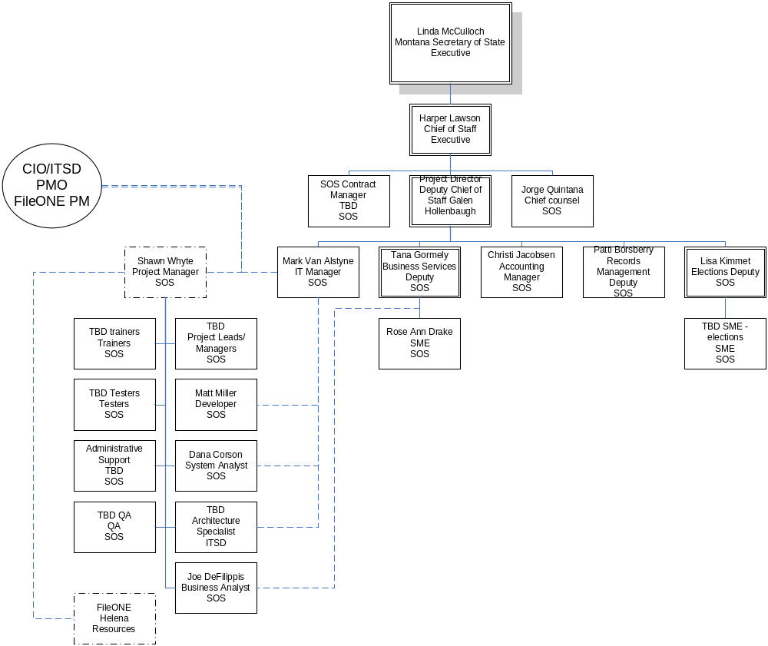
.
Key FileONE project staff will be organized according to the chart as follows:

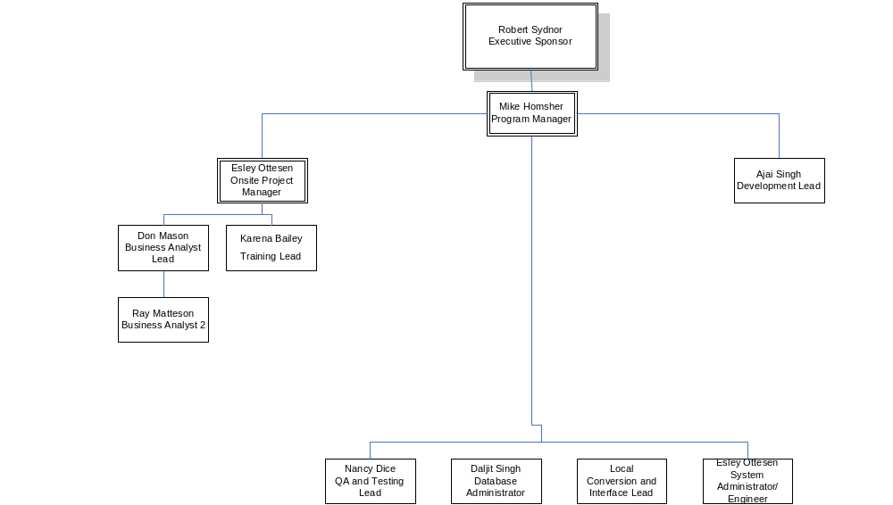
Project roles and descriptions appear below:

Role | Description
Executive Sponsor | - Oversee enterprise direction and execution  - Responsible for providing funding  - Ultimately responsible for resolution of problems raised through the escalation process  - Champion the project
Project Sponsor | - Oversee organizational direction and execution  - Responsible for monitoring funding  - Sets high level business need and requirements
Project Director | - Oversee project direction and execution  - Conduit to senior level management  - Initially responsible for management of problems raised through the escalation process
Program Manager | - Oversee direction and execution of the project within boundaries of the program  - Ensures that the project adheres to program vision, goals and objectives  - Manages the collection of projects implementing this program into various sites  - Manages and controls the infrastructure in and across installation sites  - Responsible for identifying opportunities of scale, timing and integration between install sites  - Responsible for issue resolution between install sites
Contract Managers | - Oversee execution and administration of the Contract  - Responsible for delivering the agreed upon (or amended) scope within time and budget  - Provide advice on management and strategy for the engagement  - Manage and Control impact of the Change Management process on the contract
Project Managers | - Manage the project on a daily basis with respect to schedule, deliverables, and resources  - Have authority for task assignment, budget control, and change management of the Software Development Life Cycle (SDLC).  - In charge of daily communications and formal project reviews with the client and with senior project management  - Responsible for risk management at a project level
Administrative Support | - Responsible for coordinating and delivering project administrative activities
Unit Managers | - Review deliverables  - Confirm that the system meets the documented business requirements  - Participate in Steering Committee meetings  - Make policy and procedure decisions
Project Management Office (PMO) | - Designated group or individuals who support all levels of project management  - Monitor current tasks, store all project-related data, and distribute information as required  - PMO provides the framework to ensure the project is completed on time, on budget, and to specified scope
Quality Assurance | - Provide the overall strategy for quality management and control  - Provide insight into the degree of compliance with established processes  - Conduct reviews and audits, and subsequently recommending adjustments  - Support continuous process improvement
Product Leads/Managers | - Provide development and integration support for custom modifications required for the new computer system  - Support testing, training and implementation activities
Project Leads/Managers | - Provide development and integration support for business requirements, processes and procedures relating to the new computer system  - Support testing, training and implementation activities
System Engineers | - Responsible for infrastructure and technology including computer network maintenance, setup and configuration of computer equipment, software license management, and user technical support  - Computer services staff who provide technology infrastructure, system support and technical training
Trainers | - Responsible for preparing and delivering training programs that help the support and user community learn and understand the new computer system
Testers | - Develop software testing plans, write and/or run test scripts  - Perform analysis of test results, and adjust test cases accordingly  - Validate performance of the system against approved system requirements

Key Assumptions

During the development of this SOW, the Agency was guided by certain assumptions about the Contractor’s strategic vision, work completed to date, operating environment, and availability of qualified and knowledgeable resources to support this project. These assumptions were shaped by information provided in the Contractor’s response to the Request for Proposal (RFP) and conversations with the Contractor’s representatives, as well as the contractual arrangements under which this project will be executed. This information was used to formulate the project approach, staffing requirements, program plan, project plan, and associated pricing.

Any changes in these assumptions could result in impacts to the program plan, staffing requirements, and/or the associated price. Both the Agency and the Contractor must agree on additions and changes to the project scope, deliverables, and assumptions in writing via a jointly agreed to change management process. The assumptions guiding this SOW include the following:
- Work for this contract will be performed at the Agency’s facilities at the Secretary of State’s Office at 1301 E 6th Ave, Helena, MT, the data center housed by the Information Technology Services Division of the Montana Department of Administration in Helena, MT, and the Contractor’s office in Cary, NC.
- The Agency will provide the Contractor with adequate notice concerning State-scheduled events (e.g., system outages) that impact system or staff availability.
- The Contractor and the Agency will follow a jointly agreed issues management process to document and track all project issues. The Agency’s project manager will serve as the initial escalation point to resolve issues in a timely manner to avoid schedule slippage. The Agency will address project management issues that may have an impact on the completion date. Any high priority issues, that fall outside the processes and procedures defined in the master contract must be addressed and resolved within a reasonable period of time as mutually agreed to by the Agency and the Contractor (e.g., less than one week).
- The system will adhere to the State of Montana and the Agency’s IT standards
- All software delivered will be the most recent production version supplied by the manufacturer prior to the acceptance of the detail design. All updates of commercial software used in the system will be obtained by the Agency and installed by the Contractor except by documented mutual agreement.
- The Contractor will recommend all needed software for the system and business processing over the lifespan of the contract. The Contractor will assist with the installation and configurations of all software utilized in any operation of the system over the lifespan of the contract.
- The Contractor will build or provide outward facing web services (as required by contract SOS08-1606P) via the SystemWORKS application. The joint Agency/Contractor project team will perform a detailed analysis of this functionality that will take RFP requirements, cost/benefit, gap, and the technical feasibility and functionality into account.
- Representatives from the Agency will be included in project and development team meetings that guide the development process, priorities, status updates and metrics. These meetings, the participants and frequency will be defined in the Project Management Plan.
- The Contractor will have a travel plan for staff. The goal is to have the integrated teamwork seamlessly together. Face-to-face communication is a key part of building relationships and navigating hardships. Thus, key people will be on-site for work items where the nature or importance of the work will benefit from local presence interaction. The application system will conform to system wide development standards. This will ensure that similar items on windows and reports have the same look, feel and behavior throughout the application. An example would be that all date fields use the same format MM/DD/YYYY and have a calendar date pick icon available. Exceptions to development standards will be noted in the reference material related to the object. For example, if a particular date must be in a different date format than that listed above, the reason for that variation from standard would be described in the documentation related to the object.
- Discussions regarding PSDs are not intended to exclude functional areas if not specifically mentioned. For example, if the UCC PSD is being discussed, it is assumed that the discussion includes all functional areas included in that PSD (e.g. candidate filing).
- Any changes to project plan, scope or schedule will be managed via the Change Management Process, including, but not limited to:
- Any effort or cost to investigate upgraded or new third party products or versions of a product and the cost, including any implementation of such new versions or products. If such situations arise, they will be subject to the Change Management Process with any investigation or implementation of such new or upgraded Third Party Software performed pursuant to a Task Order.

Risks

The project will use a Project Risk Management Plan to control the identification, communication, elevation and processing of risks for the duration of this contract. This creation and approval of the Risk Management Plan is included in the project plan and is expected to be delivered in the Initiation activities of the project during the General Project Phase of the project. The plan will set the expectations, schedule, plans and control mechanisms surrounding risk management activities for the project.

Scope of Work
- The purpose of this SOW is to provide the services and deliverables to design, develop and implement SIMS so that the Base System is functionally and technically operational as defined by Contract Number SOS08-1606P. In addition to other deliverables as set forth therein, SOW 1 contemplates the delivery of four principal software deliverables (PSD) each as further described and defined in SOW 1 (each a “PSD”) referred to respectively herein as follows: (1) General Project and Framework, (2) UCC (includes Candidate Filing), (3) Corporations and Trademark, and (4) Notary/Apostille and (5) Warranty which when integrated with each other will form the Base System.

The principal objective for this SOW is to implement for the Agency the FileONE software solution, SystemWORKS (the “Application Solution”) by:
- Porting the Application Solution to the State’s hardware;
- Making necessary modifications to the application so that the Base System is compliant with the RFP, the proposal submitted by the Contractor, and associated documents as specified in the Contract and SOWs.
- Making necessary configuration adjustments to align the Application Solution with the State technology infrastructure and business requirements;

The Contractor will provide services to manage the project, establish and deploy the Integrated SIMS infrastructure, and develop the strategy, design, build, deploy and operate the following four SystemWORKS project modules:
- General – System and project framework
- UCC – Uniform Commercial Code (including Candidate filing)
- Business/Trademark – Business Entity and Trademark
- Notary/Apostille – Notary and Apostille.
- Warranty - The Contractor will provide warranty on all modules from the time of implementation through the end of the one-year warranty following final acceptance of SIMS, as defined within the Contract.

Inclusions

The Project Plan will be the official master repository for all milestones, project tasks, resources, and locality of the work performed. All project tasks including Contactor, Agency, and non-deliverable tasks will be included on the project plan. The Project Plan will be a living document on the project SharePoint Portal subject to changes as required by the project. Many of these changes will be the result of the onsite and remote requirements sessions early on in the project. A Project Plan has been included with this SOW but could significantly change after the first round of onsite discovery and after all of the system requirements are documented. The Project Plan will also roll in phases and be updated and agreed to before the start of each major phase. The project phases will coordinate with the PSD areas (1) General Project and Framework, (2) UCC (includes Candidate Filing), (3) Corporations and Trademark, (4) Notary/Apostille and (5) Warranty. During the project, the Project Plan will be further broken down into a Work Breakdown Structure that will identify and roll-up lower level tasks into higher-level parent tasks. Resources, materials, hours, and dependencies will be included.

A comprehensive one-year warranty is included in the fixed fee price of this contract. The Contractor warrants that any Software and Documentation developed by the Contractor under the terms of this Contract shall conform to the specifications set forth in the RFP or documents promulgated there under in all material respects.

A table, summarizing the high-level activities and services, is included as Appendix A. This list of activities is a subset of the activities that will be performed under this SOW. This list of activities, and their estimated completion dates, may change because of milestone #1 (project initiation) – adjustments to the SOW and schedule, and may affect all milestones thereafter.

Exclusions

Back-scanning of legacy images
- Images that exist at the time of each PSD implementation module will be converted into the system image repository
- The system may be used to scan historical documents as needed and/or desired by the Agency.
Back redaction of legacy images
- The system may be used to redact images in the image repository as needed and/or desired by SOS.

Deliverables

Appendix B contains a list of deliverables required for this project. Deliverables are described at a high level with an initial listing of key content that must be included in each deliverable. The characteristics of each deliverable are included and provide initial values for start, end and dependant dates, and include responsible parties, and the roles played by both the Agency and the Contractor on each document.

Milestones

See Appendix C – project schedule

Work Approach

Methodology

The Contractor will utilize a combination of methods and tools to manage and control the activities and services under this SOW. The contractor will use a blend of FileONE’s ServiceWORKS™ implementation methodology, the Project Management Institute (PMI) Methodology and the state CIO’s Project Management Office (PMO) methodology as agreed to and outlined in the Project Management Plan. The information provided in the required deliverables, as listed in Appendix B, will be populated from the information garnered from the above blended methodology. The use of information, aggregation of performance data, and methods used to present information to the management bodies of this project will be defined in the project management plan. This project will be tracked by the state CIO’s Project Management Office (PMO).

Change Management

All modifications to the project scope, schedule and budget will be managed via the Change Management process as described within the Contract. The parties will execute Task Orders to effectuate any Modifications or other changes to the System, project plan, project schedule or any other matter relating to the performance of this Contract resulting from, or arising out of, the Change Management Process. The Change Management Process will be defined and mutually agreed upon by the parties in writing, and subject to review and written approval by the State CIO, within 30 days after the Contract is executed. Upon such agreement by the parties, the written Change Management Process shall constitute an attachment to the Contract. Baseline values will be set for all areas that will be used to measure project progress and health including but not limited to scope, schedule, iteration velocity and budget. These baselines will be set in the inception task for the project as a whole and for each PSD.

Task Order

Task Orders will be used to manage any work that has passed through the Change Management process into a body of effort that will be integrated into the project. Each Task Order will be performed for a mutually agreed upon firm fixed price. A Task Order may contain a payment schedule for progress payments (or credit) to be made during the performance of the Task Order. If the Task Order contains no payment schedule, payment (or credit) shall be made upon acceptance of the Modification in accordance with payment provisions within the Contract. The use and management of Task Orders is defined in greater detail in the Change Management Process as required by the Contract.

Issue Resolution

Any project items that are not managed by other means will be managed using the following four-step issue resolution process:

- Issue identification – issues will be identified throughout the project. Items requiring action will be issues that will be recorded using an electronic tool. The issue will be described in as much detail as possible, noting the surrounding factors, impacts and influences.
- Issue Assignment – Each issue shall be assigned a priority, due date, and a responsible party. The responsible party will be notified of the assignment and the resolution expectations surrounding the issue (this may be included in the issue documentation itself).
- Issue Review – The issues list will be reviewed as common course in team lead, and project management meetings. Progress on issue resolution will be reviewed and issues not meeting resolution expectations will be elevated for assistance.
- Issue Resolution – The responsible party will enter information regarding the resolution of the item including the steps that were taken, the results, any residual issues that came from this one, and lessons learned. The responsible party will also notify the issue originator of the resolution. The originator will update the documentation with their concurrence if possible (some data or system items will not be verifiable by the user community).

This process will be updated and streamlined as needed throughout the tool to improve performance or to fit electronic tools used to manage the process.

Tolerance

Tolerance will be defined for all project metrics defined in the inception phase of the project and each PSD. The upper and lower boundaries that can be tolerated by the steering committee on each metric will be included in the definition process for each metric, along with the phase level of measurement (project as a whole or each PSD).

Exception Planning

Exception plans will be created for each primary metric. Thus if a tolerance is breached or is forecasted to be breached, the exception plan can be put into action. The exception plan for each metric should include the action to be taken and the information to be gathered. At a minimum, the following information will be documented using an electronic tool:

- What has happened – brief description of what occurred
- How and why it happened – describe the events that led to the situation
- Options available – describe the options that are available to sort out the issue
- Recommended action – description of the team’s recommended solution
- Tolerance value review – ensure that the tolerant ranges are appropriate going forward
- Ongoing monitor plan – describe any follow up actions that need to be completed related to this issue.

Completion Criteria and Final Acceptance Criteria

Completion Criteria

The Acceptance Criteria set forth in Section 15 of the Contract provides the timelines and procedure for the acceptance of deliverables for the SIMS project. In addition to that information each Primary Software Deliverable (PSD) will be delivered to the Agency for Acceptance Testing (AT) with required documentation that includes:

- Documentation of test results from the Contractor’s internal testing processes
- Documentation of installation on the Agency’s infrastructure
- Documentation of the PSD itself (Operation guides, technical guides, user guides etc.)
- Listing of requirements which are met by the PSD
- Listing of any requirements or functional components of existing software (previously released PSD) that is directly impacted by this PSD

Each Acceptance Test Release (and iterations therein) of the Primary Software Deliverable (PSD-ATR) will be tested and accepted by the State before it will be migrated to production (go-live).

The acceptance criteria for each primary software deliverable (PSD), including performance specifications, will be created based on mutual written agreement, subject to the review and written approval of the State CIO, between the Contractor and the Agency (each a “User Acceptance Test Plan”) in accordance with the schedule in the project plan delivered to the Agency (Appendix C). The performance criteria specified in the RFP will be considered as input into this process, as will current system functionality and business process requirements.

Acceptance Testing

The Acceptance Testing process is detailed in Section 15.2 of the Contract and the acceptance requirements are set forth in Section 3.1.6 of RFP08-1606P and are not repeated here in their entirety. The key elements of the Acceptance Testing process are:

- The Contractor notifies the Agency that a primary software deliverable (PSD) is ready for testing. The contract defines a limited timeline in which the Agency shall test the deliverable.
- If the Agency notifies the Contractor in writing of any material non-conformity with the specifications in any of the deliverables within the applicable Acceptance Period, the Contractor shall promptly use reasonable efforts to correct such non-conformities at its own expense.
- The Contractor shall notify the Agency when the corrections are complete.
- The Agency shall then have the right to retest the corrected deliverable.
- The Agency and the Contractor may agree, in connection with the execution of this Contract, that certain non-conformities will be corrected after acceptance of a deliverable during the post-implementation period.

Final Acceptance

The Final Acceptance process is detailed in Section 15.3 of the Contract and acceptance requirements are set forth in Section 3.1.7 of RFP08-1606P and are not repeated here. Final acceptance is a critical activity within the life cycle of the project. The following are required for final acceptance:

- Verification of the acceptance testing and environment completion
- Verification of the update and validation of the documentation which will govern future operations, and
- Final reporting on:
    - Total budget
    - Total effort
    - Start and finish dates
    - List of deliverables
    - Restatement of Acceptance Criteria (refer to RFP08-1606P Section 3.1.7)
    - Acceptance Criteria vs. Completed System
    - Changes and/or Modifications
    - Change Management
    - Production Support
    - Open Issues
    - Final delivery documents
- Plans for any required processes, procedures, tools or deliverables for the warranty phase
- Formal signoff.

Schedule

See Appendix C – project schedule

Project Management

State Project Management Office (PMO)
The State Project Management Office supports program and project management oversight. They may provide collaborative workspaces, issue and risk management, document management, requirements and test management. The Contractor will work with the State Project Management Office to determine which components will be utilized on this project to provide the most value to the State and the project stakeholders. The various project management tools, and their applicable use on this project, will be documented within the Project Management Plan, including, but not limited to uploading relevant information to the State Project Management Office for visibility and communication with the project stakeholders.

Project Management
As stated in section 6.1 of this SOW, the Contractor will utilize a combination of methods and tools to manage and control the activities and services under this SOW. The contractor will use a blend of FileONE’s ServiceWORKS™ implementation methodology, the Project Management Institute (PMI) Methodology and the state CIO’s Project Management Office (PMO) methodology as defined by the Project Management Plan. The project will use an overarching traditional methodology, which will encapsulate the development methodology processes. The parties will integrate the Agile process used for developing the product, with a structured approach for managing the project. This will allow:

- The business, development and QA teams at FileONE to collaborate in building the optimal solution using small cycle development
- The Agency to use a more structured approach to meet our needs of ensuring and documenting contractual obligations.

The parties will use a more traditional approach for project initiation and requirements management, use a more Agile approach for the design, build and lower level testing, and then revert to a more traditional approach for regression testing, UAT and deployment. The project will produce the common PM documents for the project, but the Contractor’s team will operate in a SCRUM bubble within the framework.

State Policies Standards and Computing Environment

The State of Montana’s Policies, Standards and Computing Environment can be found on the state Web site at:
Information Technology Strategic Plan - http://itsd.mt.gov/stratplan/statewideplan.asp
Information Technology Environment - http://itsd.mt.gov/techmt/compenviron.asp
IT Policies - http://itsd.mt.gov/policy/itpolicy.asp
Software Standards - http://itsd.mt.gov/policy/software.asp

Timeline and Period of Performance

The period of performance for this project is described in detail in the Contract and will not be duplicated herein.

Compensation and Payment Schedule

The compensation and payment schedule for this project is described in detail in the Contract and will not be duplicated herein.

Travel
As defined by multiple sections and requirements in RFP08-1606, travel and accommodation expenses for the Contractor’s staff will be provided and paid for by the Contractor. Travel and accommodation expenses for the Agency’s staff related to the Client Advisory Board will be provided and paid for by the Contractor. The Agency will pay travel and accommodation costs for other required travel for Agency employees.

Miscellaneous

This section intentionally left blank.

Appendices

Appendix A – High-level Activities and services
Appendix B - Deliverables List
Appendix C – Project Schedule

Execution/Signature Block

In Witness Whereof, the parties hereto, having read this SOW for the SOS Information Management System (SIMS) to Contract Number SOS08-1606P in its entirety, do agree thereto in each and every particular.

Approved |  | Approved
Montana Secretary of State |  | FileONE
Signature |  | Signature
Print or Type Name |  | Print or Type Name
Title: |  | Title:
Date: |  | Date:

[Use this space for other applicable agency signatures]

The contractor is notified that pursuant to 2-17-514, MCA, the Department of Administration retains the right to cancel or modify any contract, project or activity that is not in compliance with the Agency’s Plan for Information Technology, the State Strategic Plan for Information Technology, or any statewide IT policy or standard.
Reviewed and Approved by:
Information Technology Services Division
Montana Department of Administration,
per MCA 2-17-512:

_____________________________________ Date:
CIO (or Agency Designee for Delegated IT Authority)

Appendix A – High-level Activities and Services

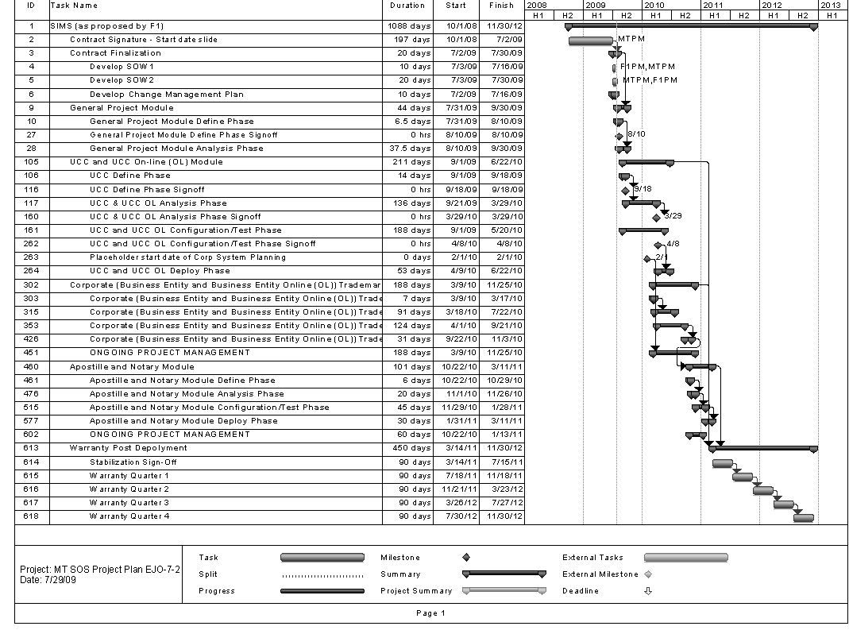

Appendix B - Deliverables List

ID | Title | DocType | Lead | Support | Description | PSD | Pre Work | General | UCC | BE | TN | Fin. Acptc | Storage Location | Tracking Location | Format
1 | Acceptance Criteria Documents per PSD | Deliverable | SOS | FileONE | Includes criteria, validation, test scripts and Sign off sheets. Should be completed by the end of the Analysis Phase of each PSD and prior to final implementation | Multiple | No | Yes | Yes | Yes | Yes | Yes | SharePoint | SharePoint | Word
2 | Acceptance Plan | Deliverable | SOS | FileONE | Describes how project will flow through the acceptance process for each PSD and final acceptance. Describes the acceptance test process, who will create the test scripts and how those scripts will be executed. Also sets responsibility for the creation of acceptance materials and who can sign off. | Multiple | No | Yes | Yes | Yes | Yes | Yes | SOS File Server | SharePoint | Word
3 | Acceptance Test Process and Scripts | Deliverable | SOS | FileONE | This is the actual acceptance test process (not the plan). Includes executing the test scripts, documentation, incident reporting, and retest. | Multiple | No | Yes | Yes | Yes | Yes | Yes | SharePoint | SharePoint | SharePoint
4 | Action Item List | Deliverable | FileONE | SOS | An electronic listing of open items that various team members need to accomplish to assist the project in moving forward. This should not include development tasks or assignments, but instead items that are more related to the project in general. | General | Yes | Yes | Yes | Yes | Yes | Yes | SharePoint | SharePoint | SharePoint
5 | Business Case | Deliverable | SOS | SOS | Captures the reasoning for the initiation of the project. Describes how this project supports the visions and goals of the business and organization. Describes how the investment will provide value, how the project will be managed, the benefits that will be realized, the staff that will be involved, and the inter-dependencies that exist. | Other | Yes | No | No | No | No | No | SOS File Server | SharePoint | Word
6 | Business Continuity Plan | Deliverable | SOS | FileONE | Describes how the business will continue to function if the system is damaged or unavailable in whole or in part. This is focused on SIMS - not the agency plan. This should be reviewed and updated for each PSD and production. Plan should include refresh schedule after production. | Multiple | No | No | Yes | Yes | Yes | No | SOS File Server | SharePoint | Word
7 | Business Requirement Refinement | Deliverable | FileONE | SOS | Planning document describing how the three-week requirement review will be conducted, how it will work, how changes will be handled, what the goals are and how the teams will be managed. Is either included in overall project plan or has its own. | General | No | Yes | No | No | No | No | SOS File Server | SharePoint | Word
8 | Change Control Plan | Deliverable | SOS | FileONE | A plan that describes how we will prepare for, manage and control the changes that will occur on the project. The process that all team members must use for change items must be clear and the understanding of the need to adhere to the plan should be included | General | No | Yes | No | No | No | No | SOS File Server | SharePoint | Word
9 | Change form | Form | SOS | FileONE | Used to uniformly document a work item that is being requested for the system. Form should track who reported the item, the status in the workflow, assignment, estimated hours, start and end dates. | Multiple | No | Yes | Yes | Yes | Yes | Yes | SharePoint | SharePoint | SharePoint
10 | Closure Plan | Deliverable | FileONE | SOS | Describes the goals that must be attained to call a PSD complete (including final acceptance). It will also describe the steps and tasks that must be competed to close a phase. Document retention will be discussed at a high level for records related to closure. | General | No | Yes | Yes | Yes | Yes | Yes | SOS File Server | SharePoint | Word
11 | Communication Plan | Deliverable | SOS | FileONE | Describes how and when communication will take place. It will also set the framework for who will use what methods to communicate what type of information to and from various target audiences. Also includes templates where appropriate or a description of what fields will be tracked in an electronic tool. | General | No | Yes | No | No | No | No | SOS File Server | SharePoint | Word
12 | Contact List | Form | SOS | FileONE | Listing of key staff members on the team and how to get a hold of them. | Multiple | No | Yes | Yes | Yes | Yes | Yes | SharePoint | SharePoint | SharePoint
13 | Data Conversion Cutover Plan | Deliverable | FileONE | SOS | Describes the schedule, tasks, assignments and dependencies that must take place to cutover to a new PSD. Roles and responsibilities must be included in this plan and it will be at a detailed level so that each team member understands their role and the downstream impacts of their work. Includes impacted systems, databases, and external agencies and how those will all be managed and tied together. | Multiple | No | No | Yes | Yes | Yes | No | SOS File Server | SharePoint | Word
14 | Conversion Mapping Documentation | Deliverable | FileONE | SOS | Shows the relationship between data in the legacy system and data in the new system. Those items without map targets must be highlighted and information for a null going forward value clearly explained. | Multiple | No | No | Yes | Yes | Yes | No | SOS File Server | SharePoint | Unknown
15 | Conversion Plan | Deliverable | FileONE | SOS | An overall plan for the conversion process that describes how the process will be managed, how issues will be dealt with, who plays what role and what the major components will be. As much information on to/from system relationships should be included. | General | No | No | No | No | No | No | SOS File Server | SharePoint | Word
16 | Corrective Action Log | Form | FileONE | SOS | Listing of items requiring corrective action and a description of what that will be. Assignment, estimated hours, start and finish dates should all be included. | Multiple | No | Yes | Yes | Yes | Yes | Yes | SharePoint | SharePoint | SharePoint
17 | Corrective Action Plan | Deliverable | FileONE | SOS | Describe how the team will develop and use corrective action to resolve issues. How issues will be researched, the construction of a corrective action, monitoring, and resolution of a CA or a plan to develop alternative action plans when the plan does not meet the goal. | General | No | Yes | No | No | No | No | SOS File Server | SharePoint | Word
18 | Database Documentation | Deliverable | FileONE | SOS | Documentation at a reasonable level that provides the reader an understanding of the constructs of the database. Material describing the database as a whole should be included - what tool, version, general constructs and high-level descriptive information. This also includes more detailed information on tables (including type - code, Corp, BE, etc.), relationships, sizing, content sizes, conceptual schema, etc. | Multiple | No | No | Yes | Yes | Yes | No | SOS File Server | SharePoint | Unknown
19 | Database schemas | Deliverable | FileONE | SOS | Graphical documents that communicate the structure of the database including technical and relational information. Tables, fields in each table and relationships therein will be included. | Multiple | No | No | Yes | Yes | Yes | No | SOS File Server | SharePoint | Unknown
20 | Deliverable Management Plan | Deliverable | SOS | FileONE | Description of how deliverables will be produced, communicated, reviewed, accepted and recorded for the project. | General | No | Yes | No | No | No | No | SOS File Server | SharePoint | Word
21 | Disaster Recovery Plan | Deliverable | SOS | FileONE | Describes the processes, policies and procedures related to the preparation for recovery from a negative event that impacts the SIMS system. | Multiple | No | No | Yes | Yes | Yes | No | SOS File Server | SharePoint | Word
22 | Forms Redesign Plan | Deliverable | FileONE | SOS | Planning document describing how the team will evaluate, restructure and normalize the forms used by external customers to interact with SOS. | General | No | Yes | No | No | No | No | SOS File Server | SharePoint | Word
23 | Forms Redesign Schedule | Deliverable | FileONE | SOS | The schedule related to the 200+ forms that must be redesigned - a portion for each PSD. The schedule may be included as task items in the project plan. | General | No | Yes | No | No | No | No | SOS File Server | SharePoint | Project (MS)
24 | Governance Model/Plan | Deliverable | SOS | FileONE | Describes the expectations, authority structure, performance goals that will be used to create consistent management, cohesive policies and processes, and decision authority for certain areas of responsibility. Includes data governance as well. | General | No | Yes | No | No | No | No | SOS File Server | SharePoint | Word
25 | Hardware Acquisition Plan | Deliverable | SOS | FileONE | Incorporates the recommended hardware into a plan for acquisition. Identifies who is responsible for what activities, how information will be communicated and the definition of criteria for when hardware is ready for installation. Includes all related staff including ITSD. | General | No | Yes | No | No | No | No | SOS File Server | SharePoint | Word
26 | Hardware Installation Plan | Deliverable | ITSD | FileONE | Coordinates all the different teams into one installation team. This plan is based off the acquisition plan, and is similar in that it identifies who is responsible for what activities, how information will be communicated and the definition of criteria for when hardware is ready for testing. Should include MS project plan. Includes all related staff including ITSD. | General | No | Yes | No | No | No | No | SOS File Server | SharePoint | Word
27 | Hardware Test Plan | Deliverable | SOS | FileONE | Builds off the acquisition and installation plans. It describes how the joint team is going to verify that the hardware is ready for system installation. The type and nature of tests will be included along with the identification of who is responsible for what activities, how information will be communicated and the definition of criteria for when hardware is ready for use. Includes all related staff including ITSD. | General | No | Yes | Yes | Yes | Yes | No | SOS File Server | SharePoint | Word
28 | Implementation Plan | Deliverable | FileONE | SOS | Describes tasks, people and systems required for implementation and migration to new system. Will include reference to other documents in this list as having completion criteria to ensure that all work is complete before implementing the PSD. | Multiple | No | No | Yes | Yes | Yes | Yes | SharePoint | SharePoint | Word
29 | Integration Design | Deliverable | FileONE | SOS | Builds off the Integration management plan to specify the technical and manual process that must be in place for external and internal systems to operate with SIMS both during the implementation phases and in production. Includes all related staff including ITSD. | Multiple | No | No | Yes | Yes | Yes | No | SOS File Server | SharePoint | Word
30 | Integration Management Plan | Deliverable | SOS | FileONE | Coordinates the activities that will need to take place in order to have SIMS successfully integrate with related systems, including those that will remain in legacy form until later PSDs are completed. The plan will identify all relationships that need to be coordinated in order to have seamless impact on other systems. Includes all related staff including ITSD. | Multiple | No | No | Yes | Yes | Yes | No | SOS File Server | SharePoint | Word
31 | Interface Design | Deliverable | FileONE | SOS | Builds off the Interface management plan to specify the technical and manual process that must be in place for external and internal systems to successfully interface data with SIMS both during the implementation phases and in production. | Multiple | No | No | Yes | Yes | Yes | No | SOS File Server | SharePoint | Word
32 | Interface Management Plan | Deliverable | FileONE | SOS | Coordinates the SIMS technical activities that will need to take place in order to have SIMS successfully interface with related systems, including those that will remain in legacy form until later PSDs are completed. The plan will identify all relationships that need to be coordinated in order to have seamless impact on other systems. | Multiple | No | No | Yes | Yes | Yes | No | SOS File Server | SharePoint | Word
33 | Issue and Escalation Process | Deliverable | SOS | FileONE | A plan that ensures that a problem does not linger in the hands of any one individual or group without resolution. The plan will describe a process (root cause analysis) which will determine where the problem resolution ownership resides, the steps that must be taken to resolve it, and the documentation that must be completed in relation to the problem. Closure of an issue and document retention will also be addressed in this plan. | General | No | Yes | No | No | No | No | SharePoint | SharePoint | SharePoint
34 | Issue Log | Deliverable | SOS | FileONE | A listing of issues related to the project that needs to be resolved in order for the project to move forward and meet its goals. This is not meant to be a repository for development questions, but project related issues that require management direction. | General | Yes | Yes | Yes | Yes | Yes | Yes | SharePoint | SharePoint | SharePoint
35 | Kick-off Meeting (project & each phase) | Meeting | FileONE | SOS | Starts up the project for the organization and is used to communicate details about the project to the team and organization. Primary project objectives, scope, business needs, team organization, risk, communication methods, cost and schedule should all be discussed. May be done in two meetings, one for the team and one for the organization. | Multiple | No | Yes | Yes | Yes | Yes | Yes | Other | SharePoint | Other
36 | Lessons Learned | Deliverable | FileONE | SOS | Each PSD phase should be reviewed with all team members to identify areas of success, difficulty and failure. These 'lessons identified' will be organized, reviewed and presented to the project management team to put measures into place to ensure the repetition of successful items, analysis of difficult items, and mitigation/corrective action for failed items. | General | No | Yes | Yes | Yes | Yes | Yes | SharePoint | SharePoint | SharePoint
37 | Maintenance and Support Plan | Deliverable | FileONE | SOS | Describes how maintenance and support will be carried out, what the roles and responsibilities are for all people involved. This plan will site the other plans that must be adhered to during this phase for each PSD. | Multiple | No | No | Yes | Yes | Yes | Yes | SOS File Server | SharePoint | Word
38 | Meeting Documentation | Meeting | Other | Other | Standard form used to record the proceedings of project meetings. | Multiple | No | Yes | Yes | Yes | Yes | Yes | SOS File Server | SharePoint | Word
39 | Organization Chart | Deliverable | FileONE | SOS | Diagram showing the structure of the project and the relationships and relative authority of its parts and positions/roles. This will be reviewed and updated quarterly or when significant staff changes occur. | Multiple | Yes | Yes | Yes | Yes | Yes | Yes | SOS File Server | SharePoint | Visio
40 | Performance Measurement Plan | Deliverable | SOS | FileONE | Documents the process that the project will use to measure the performance of all project members in relation to the tasks that are their responsibility. | General | No | Yes | No | No | No | No | SOS File Server | SharePoint | Word
41 | Performance Review | Deliverable | SOS | FileONE | This is the review. The documentation leading up to the review, communication of that information, and documentation resulting from the review are conducted under this task. | Multiple | No | Yes | Yes | Yes | Yes | Yes | SOS File Server | SharePoint | SharePoint
42 | Performance Review Plan | Deliverable | SOS | FileONE | Describes the process that will be used to gather information about performance and how that information will be given to teams, team members, or management. May be combined with Measurement plan | General | No | Yes | No | No | No | No | SOS File Server | SharePoint | Word
43 | Preliminary Scope Statement | Deliverable | SOS | SOS | Describes the projects goals and communicates what is and is not intended to be part of the project. It is part of the vision for the system. | Other | Yes | No | No | No | No | No | SharePoint | SharePoint | Word
44 | Project Charter | Deliverable | SOS | FileONE | Communicates the high-level parameters of the project. By including the vision, scope, goals, resources and roles, it shares the constructs of what management approved. | General | Yes | Yes | No | No | No | No | SOS File Server | SharePoint | Word
45 | Project Initiation Document | Deliverable | FileONE | SOS | Outlines how the project is going to be ramped up. It documents high-level goals and documents the obstacles the project wants to avoid. This is the initial document to get the various teams and team members moving in the same direction at the same time. | General | No | Yes | No | No | No | No | SOS File Server | SharePoint | Word
46 | Project Management Plan | Deliverable | FileONE | SOS | Communicates the major parameters of the project. It is a summary of what the project is intended to accomplish, the timeline expected, and the resources that are expected to be involved in particular roles. | General | No | Yes | No | No | No | No | SOS File Server | SharePoint | Project (MS)
47 | Project Schedule | Deliverable | FileONE | SOS | A full project schedule that includes the work breakdown structure for the project. The tasks, assignments and dependencies are shown and resource conflicts and overbooking are removed. | Multiple | Yes | Yes | Yes | Yes | Yes | Yes | MS Project | MS Project | Project (MS)
48 | Project Status Report | Deliverable | FileONE | SOS | Provides transparency into the status of all work items encapsulated and related to the project. Will show progress, remaining work, issues, risks, decision points, and items of general interest. Schedule is TBD. Project status report will be rolled into the status report required by MT PMO (SOS PM completes). | Multiple | No | Yes | Yes | Yes | Yes | Yes | SOS File Server | SharePoint | Word
49 | Quality Management Plan | Deliverable | FileONE | SOS | Describes how we are going to ensure a high quality operation. Will document the plan, implementation, and assessment used for quality assurance and quality control activities including deliverables, outputs, standards and metrics. It also outlines action that will be taken when quality standards are not met. | General | No | Yes | No | No | No | No | SOS File Server | SharePoint | Word
50 | Records Management Plan | Deliverable | SOS | FileONE | Describes how the materials generated by and related to the project will be managed. This includes a glossary of terms to reduce misinterpretation. The document will identify document types, how they will be processed, retained, and will describe what the final outcome should be for each artifact. | General | No | Yes | No | No | No | No | SOS File Server | SharePoint | Word
51 | Responsibility Assignment Matrix | Deliverable | FileONE | SOS | Each project task, decision or deliverable will be assigned a responsible party. The owner is responsible for getting the item completed, even if a team is required to complete the work. The ideal will be to have this in an electronic tool (not a spreadsheet) so it can be viewed by all. | Multiple | No | Yes | Yes | Yes | Yes | Yes | SOS File Server | SharePoint | Project (MS)
52 | Risk Management Plan | Deliverable | SOS | FileONE | Provides the approved mechanism for handling risks as they are identified and realized. This plan ensures that risks are handled consistently by all team members and sets the expectation for what will happen when an event is encountered. | General | No | Yes | No | No | No | No | SOS File Server | SharePoint | RightNow
53 | Risk Register | Deliverable | SOS | FileONE | Listing of risks identified with calculations to allow management to proactively manage the pipeline of possible risk items that may occur on the project. The Register should be reviewed on a regular basis, as appropriate for the phase of the project. | Multiple | Yes | Yes | Yes | Yes | Yes | Yes | SharePoint | SharePoint | SharePoint
54 | ROI documentation Plan | Deliverable | SOS | FileONE | Describes how the ROI and other such factors will be calculated for the project. Early definition of desired ROI measures will allow the project team to record the data that will be needed to produce the metrics. | General | No | Yes | No | No | No | Yes | SOS File Server | SharePoint | Excel
55 | Schedule Management Plan | Deliverable | FileONE | SOS | Describes how the project team will manage the project schedule. Details on the actual files, where they will be stored, who can update them, how versions will be managed, and how the team will adjust task values are all addressed in this plan. | General | No | Yes | No | No | No | No | SOS File Server | SharePoint | Word
56 | Scope Management Plan | Deliverable | FileONE | SOS | Defines and controls what is and is not included in the project. At a detail level, define the work that needs to be accomplished to deliver the system with the specified features and functions. Document how the project scope will be defined, verified, controlled, and how the work breakdown structure (WBS) will be created and defined. | General | No | Yes | No | No | No | No | SOS File Server | SharePoint | Word
57 | Scope Statement | Deliverable | SOS | SOS | Describes the major objectives of the project, what is not included in the project, and general requirements, deliverables and milestones of the project. | Other | Yes | No | No | No | No | No | SOS File Server | SharePoint | Word
58 | Sign-off Sheets (if not electronic) | Form | FileONE | SOS | Used to document acceptance of deliverables and other significant work items | Multiple | No | Yes | Yes | Yes | Yes | Yes |  |  | RightNow
59 | Staffing Management Plan | Deliverable | FileONE | SOS | Outlines the members of the team, the roles they will fill, and how staff will be rolled onto and off of the project. Transition tasks will be described. Describes how the resources of all involved organizations will be included in the project. Ensures effective and efficient deployment of resources when they are needed | General | No | Yes | No | No | No | No | SOS File Server | SharePoint | Word
60 | Stakeholder Analysis | Deliverable | SOS | FileONE | Identifies and assesses the importance of key people, groups, and organizations that many significantly influence the project (positively or negatively). Analysis of the need to include these stakeholders in various parts of the project is the key result of this document | General | Yes | Yes | No | No | No | No | SOS File Server | SharePoint | Word
61 | Statement of Work | Deliverable | SOS | FileONE | Describes the work to be done in detail and specifies the hardware and software involved and the exact nature of the work to be done | Other | Yes | No | No | No | No | No | SOS File Server | SharePoint | Word
62 | Status Report | Meeting | FileONE | SOS | Used to uniformly report the status of the project on a regular basis. Should include work completed, work remaining, and the status of any issues, defects, changes. This is the lowest level reporting which will be rolled into the project status report. | Multiple | No | Yes | Yes | Yes | Yes | Yes | SOS File Server | SharePoint | Word
63 | Steering Committee Meeting & Minutes | Meeting | SOS | FileONE | Used to communicate project status, resolve issues, garner decisions, and report all open issues, changes, and requests. | Multiple | No | Yes | Yes | Yes | Yes | Yes | SOS File Server | SharePoint | Word
64 | Steering Committee Status Report | Form | SOS | FileONE | Formal report to the Steering Committee showing project status, resolve issues, garner decisions, and report all open issues, changes, and requests. | Multiple | No | Yes | Yes | Yes | Yes | Yes | SOS File Server | SharePoint | Word
65 | System Design Documents | Deliverable | FileONE | SOS | Documentation provided on system areas that are reworked or custom functionality. Detailed system design documents are based on, and traceable to, the requirements. These design documents, as well as the requirements, will serve as a basis for test scripts. For non interface/conversion development use cases and high-level functional requirement specifications will be provided but the detailed internal engineering design documentation will not be provided | Multiple | No | No | Yes | Yes | Yes | No | SOS File Server | SharePoint | Word
66 | Task Order | Form | FileONE | SOS | Formal document used to add work items to the project whether in or out of scope. Order must fully define the work, schedule, staff, impact, needs and analysis used to generate the request. | Multiple | No | Yes |  |  |  |  | SharePoint | SharePoint | SharePoint
67 | Team Meetings & Minutes | Meeting | Other | Other | Standard format used to record activities and events within team meetings. | Multiple | No | Yes | Yes | Yes | Yes | Yes | SOS File Server | SharePoint | Word
68 | Technical Support Operations Manual | Deliverable | FileONE | SOS | Describes the operational characteristics of the system in order to allow support work to be understood and managed by new team members as needed. Should include all tasks required to keep the system and business functions operational | Multiple | No | No | Yes | Yes | Yes | Yes | SOS File Server | SharePoint | Word
69 | Terms of Reference | Deliverable | FileONE | SOS | Glossary of terms | Multiple | No | Yes | Yes | Yes | Yes | Yes | SharePoint | SharePoint | SharePoint
70 | Testing Plan | Deliverable | FileONE | SOS | Describes the workflow expected for the test process for the project. Roles, responsibilities, documents, and retention should all be included. | Multiple | No | No | Yes | Yes | Yes | Yes | SOS File Server | SharePoint | Word
71 | Testing Results (each phase & environment) | Deliverable | SOS | FileONE | Result information for all testing scenarios must be recorded in order to determine the level of completion of each phase of the project. | Multiple | No | No | Yes | Yes | Yes | Yes | SharePoint | SharePoint | SharePoint
72 | Testing Schedule | Deliverable | SOS | FileONE | Detailed listing of the test activities that will be conducted and the responsibility for each work item in the schedule. | Multiple | No | No | Yes | Yes | Yes | Yes | SOS File Server | SharePoint | Project (MS)
73 | Training Plan | Deliverable | FileONE | SOS | Describes how all system users will be brought up to a competent level in their role interacting with SIMS. The tools, techniques and methods will be described in detail along with the staff that will be conducting and taking the training courses. | General | No | No | Yes | Yes | Yes | No | SOS File Server | SharePoint | Word
74 | Training Schedule | Deliverable | FileONE | SOS | Detailed listing of the training activities that will be conducted and the responsibility for each work item in the schedule. | Multiple | No | No | Yes | Yes | Yes | No | SOS File Server | SharePoint | Project (MS)
75 | User Feedback Plan | Deliverable | SOS | FileONE | Describes a mechanism for end users and project participants to provide feedback to the project team about issues that concern them and what will happen with those items after being submitted. | General | No | Yes | No | No | No | No | SharePoint | SharePoint | SharePoint
76 | User Guide - Business | Deliverable | FileONE | SOS | Provides detail instruction on how the business of SOS is accomplished through the system. | Multiple | No | No | Yes | Yes | Yes | No | SOS File Server | SharePoint | Word
77 | User Guide - technical | Deliverable | FileONE | SOS | Provides detail instruction on how the technical aspects of the system have been constructed. Includes software configuration requirements for environment initial build out. It outlines the primary work tasks needed to keep the system operational, and includes any hot fixes, non-standard work items, work around or tricky tasks that must be done to keep the system up, running, and healthy. | Multiple | No | No | Yes | Yes | Yes | No | SOS File Server | SharePoint | Word
78 | Work Breakdown Structure | Deliverable | FileONE | SOS | Identification of low level tasks into higher-level parent tasks. Resources, materials, hours, and dependence should be included. | Multiple | No | Yes | Yes | Yes | Yes | Yes | SOS File Server | SharePoint | Project (MS)

Appendix C – Project Schedule

